**Supplementary materials**

|  |  |  |  |
| --- | --- | --- | --- |
| **Species** | **Functional type** | **Site** | **Distribution zones** |
| *Cassiope tetragona* | Evergreen shrub | Alexandra Fiord | Erect-shrub tundra (S1); Graminoid, prostrate dwarf-shrub, forb, moss tundra (G2); Prostrate / hemi-prostrate dwarf-shrub, lichen tundra (P2) |
| *Dryas integrifolia* | Evergreen shrub | Alexandra Fiord | Graminoid, prostrate dwarf-shrub, forb, moss tundra (G2); Prostrate dwarf-shrub, herb, lichen tundra (P1);  Prostrate / hemi-prostrate dwarf-shrub, lichen tundra (P2) |
| *Oxyria digyna* | Forb | Alexandra Fiord | Graminoid, forb, cryptogam tundra (G1);  Graminoid, prostrate dwarf-shrub, forb, moss tundra (G2); Prostrate / hemi-prostrate dwarf-shrub, lichen tundra (P2) |
| *Papaver radicatum* | Forb | Alexandra Fiord | Cryptogam, herb barren (B1); Graminoid, forb, cryptogam tundra (G1); Graminoid, prostrate dwarf-shrub, forb, moss tundra (G2) |
| *Luzula arctica/confusa* | Graminoid | Alexandra Fiord | Cryptogam, herb barren (B1);  Prostrate dwarf-shrub, herb, lichen tundra (P1);  Prostrate / hemi-prostrate dwarf-shrub, lichen tundra (P2) |
| *Eriophorum vaginatum* | Graminoid | Daring Lake | Tussock- sedge, dwarf-shrub, moss tundra (G4);  Erect-shrub tundra (S1) |
| *Rhododendron tomentosum*  *ssp. decumbens* | Evergreen shrub | Daring Lake | Cryptogam, barren, dwarf-shrub complex (B2b);  Prostrate/hemi-prostrate dwarf-shrub, lichen tundra (P2);  Low-shrub, moss tundra (S2); Sedge, moss, dwarf-shrub wetland complex (W2) |
| *Salix pulchra/planifolia* | Deciduous shrub | Daring Lake | Sedge, moss, dwarf-shrub wetland complex (W2); Tussock- sedge, dwarf-shrub, moss tundra (G4) |
| *Saxifraga tricuspidata* | Forb | Daring Lake | B4 Carbonate mountain complex elevation belt d & e |
| *Vaccinium*  *vitis-idea* | Evergreen shrub | Daring Lake | Cryptogam, barren, dwarf-shrub complex (B2b);  Tussock- sedge, dwarf-shrub, moss tundra (G4);  Erect-shrub tundra (S1);  Low-shrub, moss tundra (S2) |
| *Betula glandulosa* | Deciduous shrub | Daring Lake | Cryptogam, barren, dwarf-shrub complex (B2b);  Sedge, moss, low-shrub wetland complex (W3);  Low-shrub, moss tundra (S2) |
| *Oxytropis nigrescens* | Forb | Daring Lake | B4 Carbonate mountain complex elevation belt d & e |

**Table S1.** Names, plant functional types, study site location and circum- polar/boreal distribution information for the 12 tundra species included in this synthesis. Distribution zones are from the Circumpolar Arctic Vegetation Map (CAVM, Table S1) (Raynolds et al. 2019). Species with dual names (/) had two indistinguishable (and sometimes hybrid) congeneric species within the same plots and their data were lumped.



a)

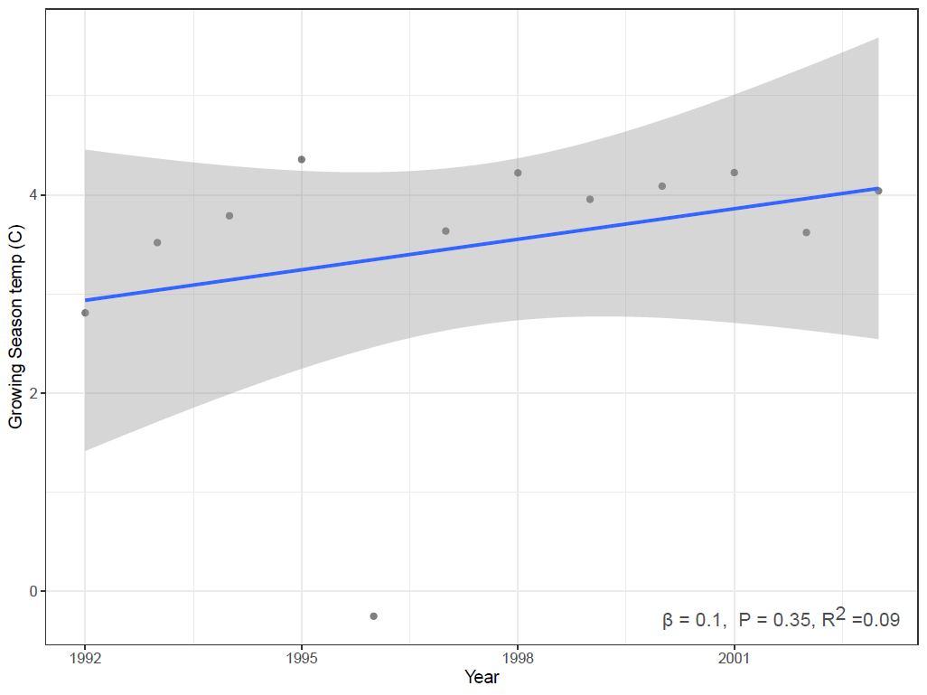

b)

**Fig S1. a)** Observed snow free day of year (DOY) for a subset of individuals from each species in each year at Daring Lake from 2001-2022. Linear mixed regression (with a year random intercept term) shows a negative, but not significant, pattern over the period of this study suggesting a slight advancement in snow free dates. **b)** Average growing season (June - Aug) air temperature (1.5 m height) at Alexandra Fiord plotted by year from 1992-2003. Simple linear regression shows a slightly positive but non-significant warming pattern over the period of this study. Regression lines are plotted by the function ‘geom_smooth’ in the R package ggplot2 (Wickham 2009).

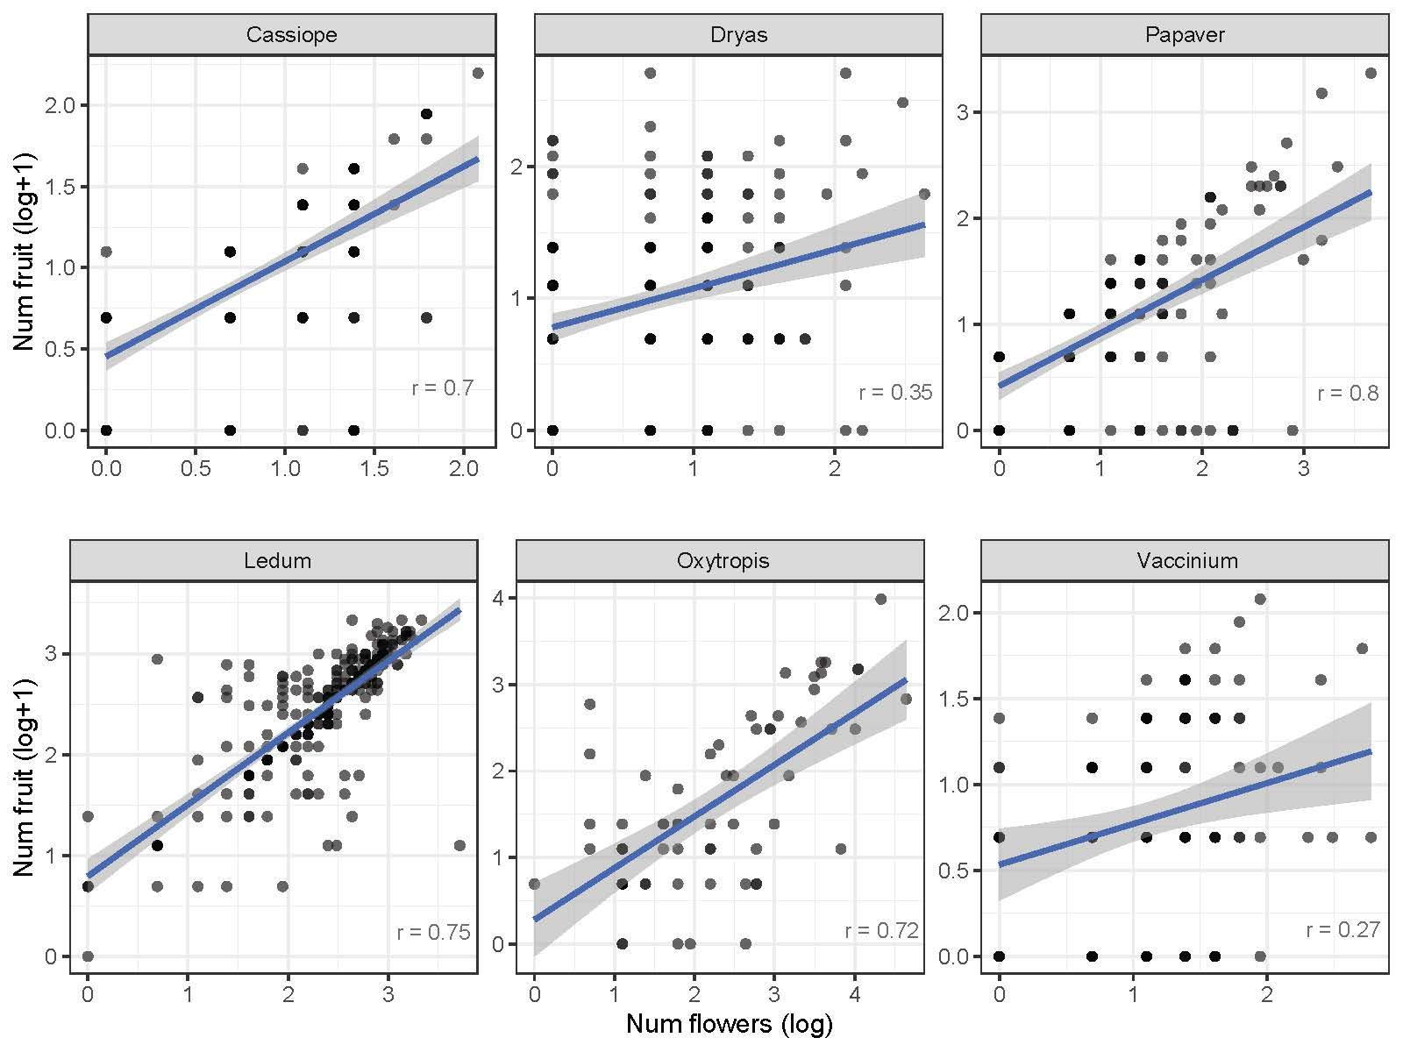

**Fig S2.** Relationships between flower number and fruit number of individual plants across species. Pearson’s correlation values (r) are shown in the bottom right and simple linear regressions are plotted on raw data with the function ‘geom_smooth’ in the R package ggplot2 (Wickham 2009). Species in the top row are from Alexandra Fiord and in the bottom row are from Daring Lake.

**Appendix 1- Model performance**

**Flower number- Daring Lake**

**Posterior predictive checks**

DOY flower

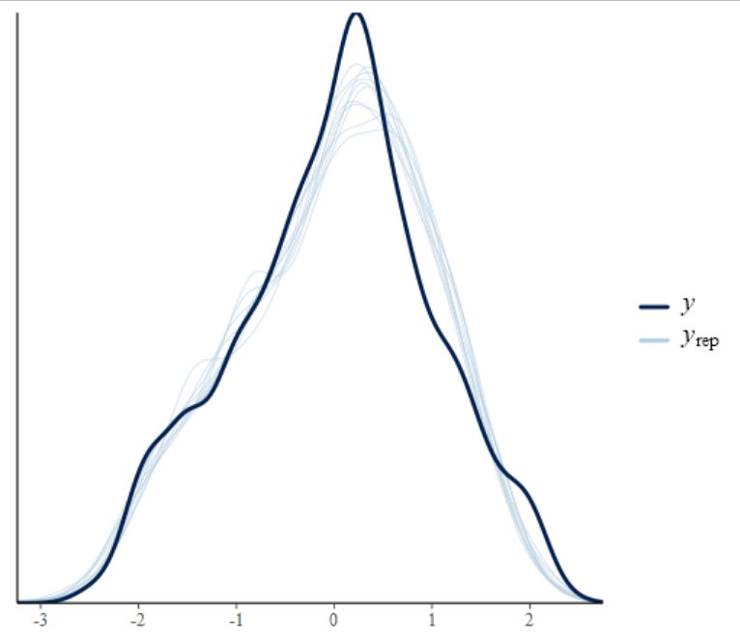

log(flower count)

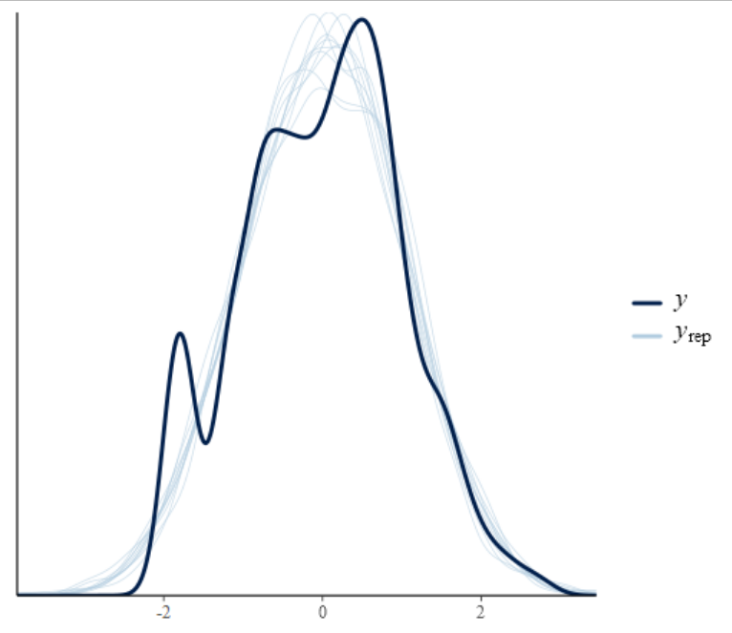

**Leave one out (LOO) cross validation**

Computed from 15000 by 1584 log-likelihood matrix

Estimate SE

elpd_loo -2553.7 57.6

p_loo 149.4 5.3

looic 5107.4 115.3

------

Monte Carlo SE of elpd_loo is 0.1.

Pareto k diagnostic values:

Count Pct. Min. n_eff

(-Inf, 0.5] (good) 1583 99.9% 2820

(0.5, 0.7] (ok) 1 0.1% 811

(0.7, 1] (bad) 0 0.0% <NA>

(1, Inf) (very bad) 0 0.0% <NA>

All Pareto k estimates are ok (k < 0.7)

**Fruit number- Daring Lake**

**Posterior predictive checks**

DOY flower

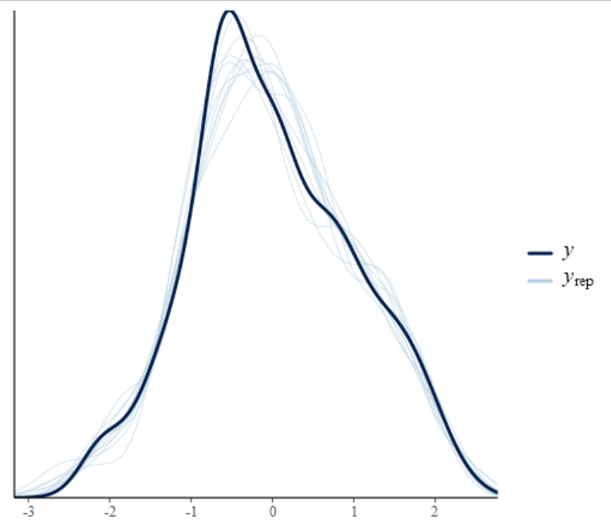

log(fruit count)

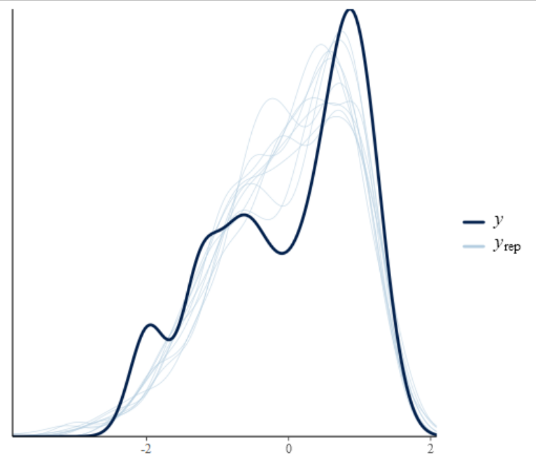

**Leave one out (LOO) cross validation**

Computed from 15000 by 510 log-likelihood matrix

Estimate SE

elpd_loo -682.4 42.2

p_loo 84.0 8.3

looic 1364.9 84.5

------

Monte Carlo SE of elpd_loo is NA.

Pareto k diagnostic values:

Count Pct. Min. n_eff

(-Inf, 0.5] (good) 475 93.1% 1372

(0.5, 0.7] (ok) 25 4.9% 692

(0.7, 1] (bad) 9 1.8% 30

(1, Inf) (very bad) 1 0.2% 51

**LOO cross validation refit (i.e. reloo)**

Computed from 15000 by 510 log-likelihood matrix

Estimate SE

elpd_loo -684.0 42.3

p_loo 85.5 8.8

looic 1368.0 84.6

------

Monte Carlo SE of elpd_loo is 0.4.

Pareto k diagnostic values:

Count Pct. Min. n_eff

(-Inf, 0.5] (good) 481 94.3% 24

(0.5, 0.7] (ok) 29 5.7% 291

(0.7, 1] (bad) 0 0.0% <NA>

(1, Inf) (very bad) 0 0.0% <NA>

All Pareto k estimates are ok (k < 0.7).

**Flower number- Alexandra Fiord**

**Posterior predictive checks**

DOY flower

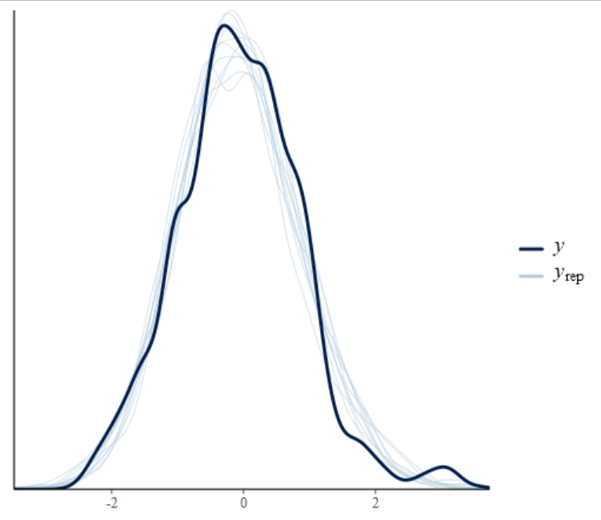

Flower count

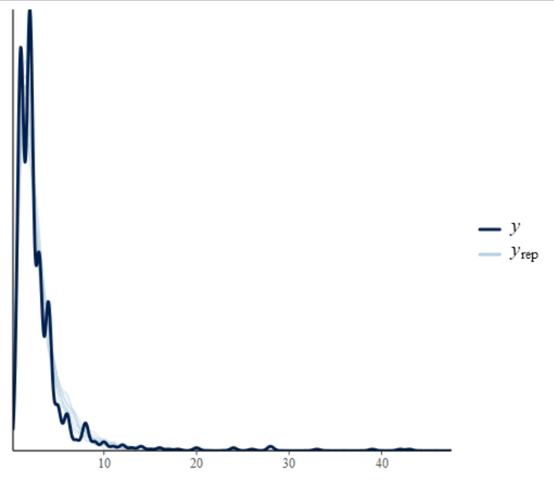

**Leave one out (LOO) cross validation**

Computed from 15000 by 930 log-likelihood matrix

Estimate SE

elpd_loo -2540.7 51.0

p_loo 89.4 4.7

looic 5081.4 102.1

------

Monte Carlo SE of elpd_loo is 0.1.

Pareto k diagnostic values:

Count Pct. Min. n_eff

(-Inf, 0.5] (good) 928 99.8% 2518

(0.5, 0.7] (ok) 2 0.2% 440

(0.7, 1] (bad) 0 0.0% <NA>

(1, Inf) (very bad) 0 0.0% <NA>

All Pareto k estimates are ok (k < 0.7).

**Fruit number- Alexandra Fiord**

**Posterior predictive checks**

DOY flower

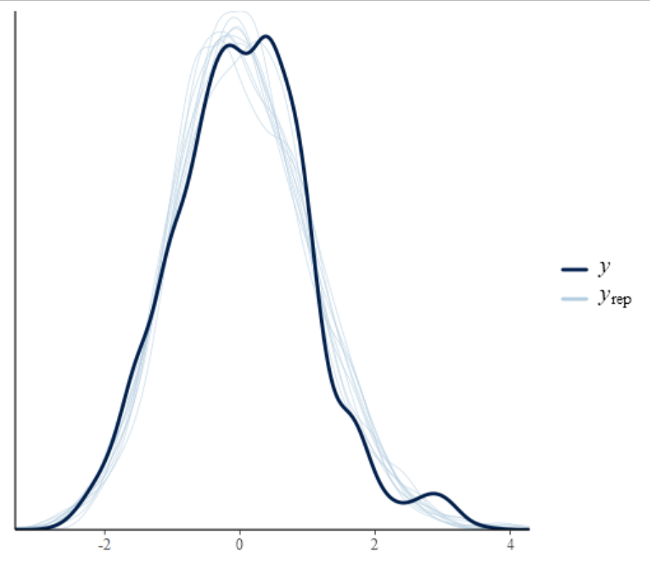

Fruit count

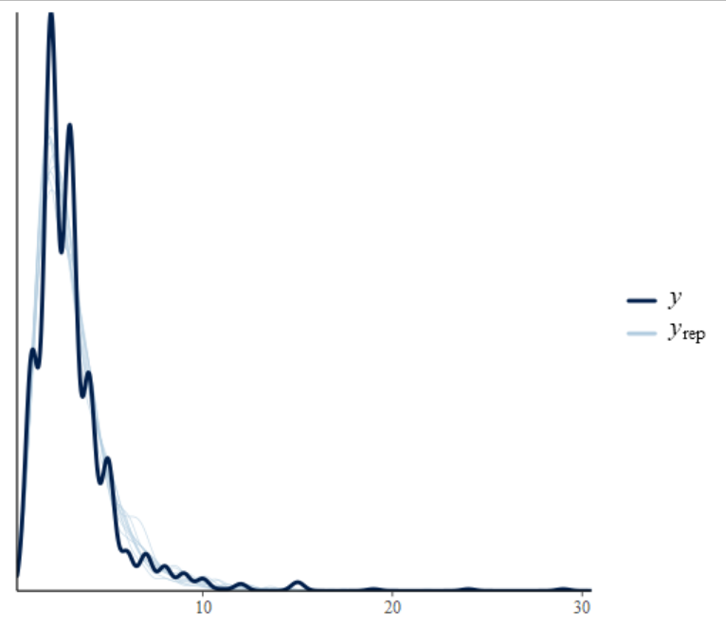

**Leave one out (LOO) cross validation**

Computed from 15000 by 1013 log-likelihood matrix

Estimate SE

elpd_loo -2728.8 42.6

p_loo 74.2 3.6

looic 5457.7 85.2

------

Monte Carlo SE of elpd_loo is 0.1.

Pareto k diagnostic values:

Count Pct. Min. n_eff

(-Inf, 0.5] (good) 1011 99.8% 4105

(0.5, 0.7] (ok) 2 0.2% 2294

(0.7, 1] (bad) 0 0.0% <NA>

(1, Inf) (very bad) 0 0.0% <NA>

All Pareto k estimates are ok (k < 0.7).

**References**

Hill, G. B., and G. H. R. Henry. 2011. Responses of High Arctic wet sedge tundra to climate warming since 1980. Global Change Biology 17:276–287.

Raynolds, M. K., D. A. Walker, A. Balser, C. Bay, M. Campbell, M. M. Cherosov, F. J. A. Daniëls, P. B. Eidesen, K. A. Ermokhina, G. V. Frost, B. Jedrzejek, M. T. Jorgenson, B. E. Kennedy, S. S. Kholod, I. A. Lavrinenko, O. V. Lavrinenko, B. Magnússon, N. V. Matveyeva, S. Metúsalemsson, L. Nilsen, I. Olthof, I. N. Pospelov, E. B. Pospelova, D. Pouliot, V. Razzhivin, G. Schaepman-Strub, J. Šibík, M. Yu. Telyatnikov, and E. Troeva. 2019. A raster version of the Circumpolar Arctic Vegetation Map (CAVM). Remote Sensing of Environment 232:111297.

Wickham, H. 2009. Elegant Graphics for Data Analysis. Springer Publishing Company, Incorporated.